Lab 1 Report (This is the cover page)

Name:

ID:

Use the lab assignment as the cover page!!!

1. Schematic and Compilation Console

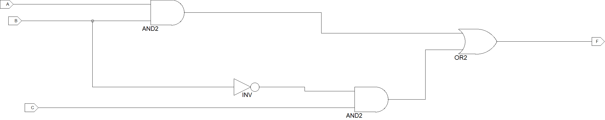

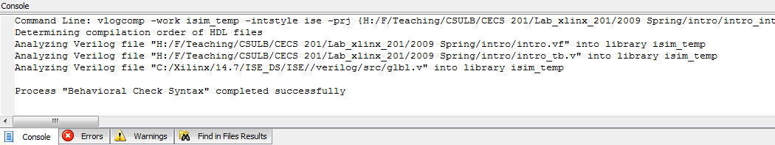

Comments and explanation of the project design!!!

1. Testbench

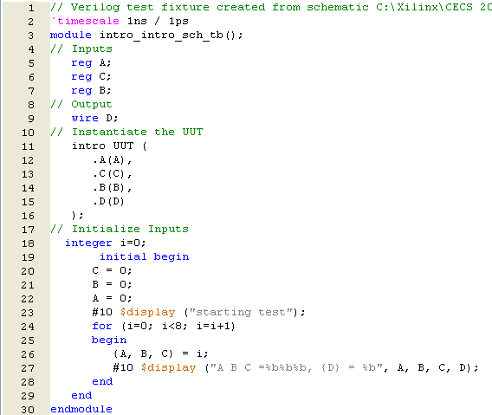

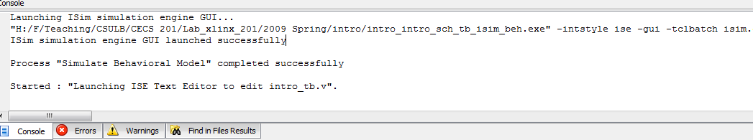

Comments to the code:

1. Simulation Results showing all eight combinations

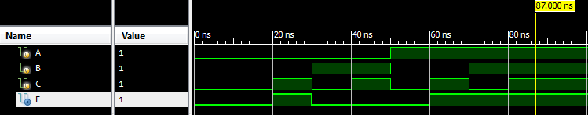

Analysis of the simulation results: